**S3 Bucket Implementation for E-commerce Platform**

Step1:

Created 1 static wesite with index.html file

Step2:

Upload it in amazon S3 bucket. For that I created one S3 bucket

Step3:

Set the Bucket policy

Step4:

Go to Cloud Front

Step5:

Create 1 distribution

In that provide your bucket name

After creation copy that domain name

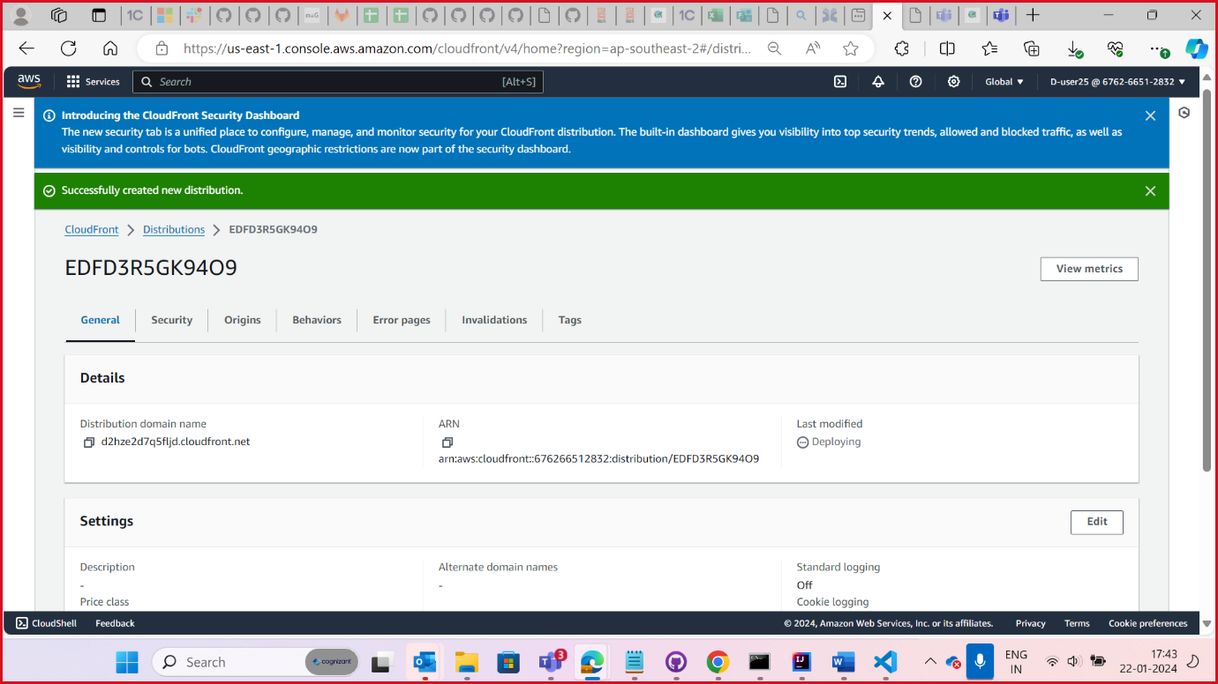

Step6:

Paste that domain name in web browser.

Now your website is secured.

